Lesson Plan #_3_
The Tokugawa Shogunate Era

Introduction:
In this lesson students will learn more about the Shogun system in Feudal Japan. More importantly, they will learn about the Tokugawa Shogunate. The Tokugawa Shogunate was one of the longest lasting Shogunate system in Japan because of it stayed within the Tokugawa family. The Tokugawa Era brought forth a unification of the state and a national system. Before the Tokugawa Era Japan was medieval and was a warring state. The Tokugawa Era brought forth peace and order for 250 years.

Objectives:
Content/Knowledge:
- Students will be able to analyze primary and secondary sources on the occurrences during the Tokugawa era.
- Students will be able to work in different stations in order to expand their knowledge on the different events and views of the Tokugawa Era.
- Students will be able to state reasons as to why this system was very successful for it to have lasted for 250 years...

Process/Skills:
- Students will be able to move from station to station in an orderly manner without a problem
- Students will be able to work effectively and appropriately within groups.
- Students will be able to analyze the different primary and secondary sources at each of the six stations.

Values/Dispositions:
- Students will be able to determine the effects that the this Era had on the people.
- Students will be able to empathize with the people of this Era on how they reacted towards the rule of the Tokugawa Shogunate.

Standards:

State – Illinois Learning Standards
- 16.A.3b: Make inferences about historical events and eras using historical maps and other historical sources.
- 18.B.3a: Analyze how individuals and groups interact with and within institutions (e.g., educational, military).

State – Common Core Standards
- Grade 6-8: Key Ideas and details: 1. Cite specific textual evidence to support analysis of primary and secondary sources.
- Grade 6-8: Craft and Structure: 4. Determine the meaning of words and phrases as they are used in a text, including vocabulary specific to domains related to history/social studies

National – National Council for the Social Studies Standards
- Standard 5C: identify examples of institutions and describe the interactions of people with institutions;
- Standard 5E: identify and describe examples of tensions between and individual’s beliefs and government policies and laws

National – National Standards for World History
- Standard 6A: The student understands major global trends from 1450 to 1770.
Syntax – Procedures


- White Hat – Objective:
- Teacher Instructions
- The teacher will present a video about Ieyasu Tokugawa and how he forged the new ways of Feudal Japan.
- Resource
- “Will of the Shogun” Video
- Student Activity
- Students will watch the video and take notes on what they learn about the Tokugawa Shogunate system and for what reasons it was successful.
- Yellow Hat – Positive:
- Teacher Instructions
- The teacher will provide a primary source for students to read and analyze on a positive aspect.
- The teacher will also provide questions to answer along with this primary source and some of the questions will have students looking at the positive outcome with the
- Resource
- Primary source “Tokugawa Ieyasu on Military Government and the Social Order”
- Student Activity
- Students will read and analyze the positive aspects of the primary document on Ieyasu Tokugawa
- Students will have to argue as to why Tokugawa’s views will work
- Students will answer questions following the reading.
- Black Hat – Negative:
a. Teacher Instructions
1. The teacher will provide a primary source for students to read and analyze on a negative aspect.
- Resource
- Primary source “THE EDICTS OF THE TOKUGAWA SHOGUNATE : EXCERPTS FROM LAWS OF MILITARY HOU SEHOLDS (BUKE SHOHATTO) , 1615”
- Student Activity
- Students will read and analyze the negative aspects of the primary document that will be provided.
- Students will have to argue as to why these edicts will not work.
- Students will answer question following the reading.
- Blue Hat – Process:
- Teacher Instructions
- The teacher will hold a class discussion in which students will have to regulate a debate.
- The teacher will instruct students that they have to debate whether the Tokugawa Shogunate was fair or not with its people by using information about the previous lesson on the class structure and the newly acquired information from this lesson.
- The teacher will split the students into three groups. One group will be on the positive side of the Tokugawa Shogunate, the other group will be against it, and the third will be neutral.
- Resource
- Information from previous lesson (Lesson 2)
- Information and facts from this lesson (videos and primary sources)
- Student Activity
  - Students will be in charge of holding a debate about the Shogunate system.
  - Students will be split into three groups and take up their roles.
  - The Neutral group of students will be the center of this assignment because they have to keep chaos in order and not let things get out of hand
- Red Hat – Intuitive:
- Teacher Instructions
  - The teacher will provide students a written assignment prompt that will have them write about what their “gut feeling” was while they were learning about the Tokugawa Period.
  - The teacher will then show a short video on the reasons as to why the Tokugawa Shogunate declined to help the students better analyze and synthesis an answer for their writing assignment.
- Resource
- Video “The Decline of the Tokugawa Shogunate”
- Student Activity
- Students follow the directions on the written assignment hand out and write what they felt was going to happen as the Tokugawa Era was coming to an end.
- Students will view “The Decline of the Tokugawa Shogunate” in order to better infer and analyze the reasons as to why the Tokugawa Shogunate came to an end.
- Green Hat – Creative:
- Teacher Instructions
- The Teacher will provide a written assignment that will have the students create their own Shogunate.
- The teacher will instruct students to write using evidence from what they learned about the Tokugawa Era and how they can either make some of the original concepts better or if they would eliminate them completely.
- Resource
- The use of previously learned material (i.e. Videos and Primary sources)
- Student Activity
- Students will create their own Shogunate.
- Students will use information that they previously learned in order to support their rules and edicts.
- Students will have to argue as to how and why they would change or eliminate a previous edict from Ieyasu Tokugawa.
- Students will create this in the form of a scroll to add more entertainment to the assignment.

White Hat

Students will view and analyze the following video in order to infer the facts on what happened during the Tokugawa Shogunate. Students will also take notes and use this to formulate ideas for assignments at other stations.

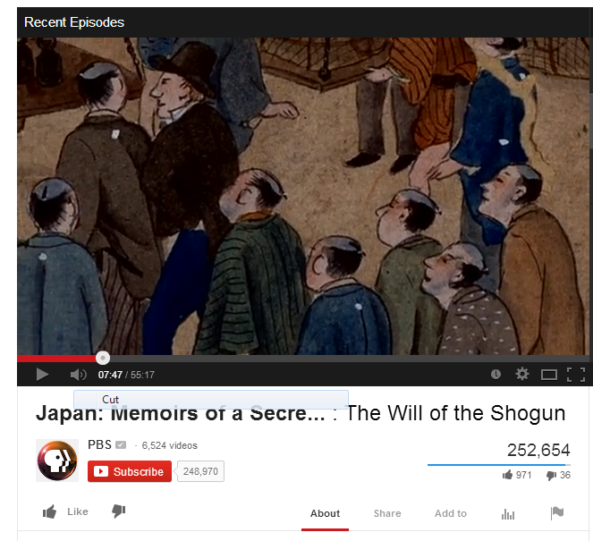

http://www.youtube.com/watch?v=KljfHk39FQs&list=TLiY4zDmAXyYdY4j_xjkNnsrRA3QtsvnRv

Yellow Hat
Introduction

Tokugawa Ieyasu (1543-1616) was the third of the three great unifiers of Japan and the founder of the Tokugawa shogunate that ruled Japan from 1603 to 1868. The establishment of a stable national regime was a substantial achievement, as Japan had lacked effective and durable central governance for well over a century prior to Ieyasu’s rise.

Creating the Tokugawa system of rule required a variety of sweeping political and social reforms, none perhaps with
a more profound impact than the division of society into four hereditary status groups (often called classes) based on occupation, known in Japanese as the shinōkōshō (samurai, peasants, artisans, merchants). In this short document, written by an unidentified retainer in the early seventeenth century, Ieyasu’s conception of the Tokugawa social hierarchy is recorded.

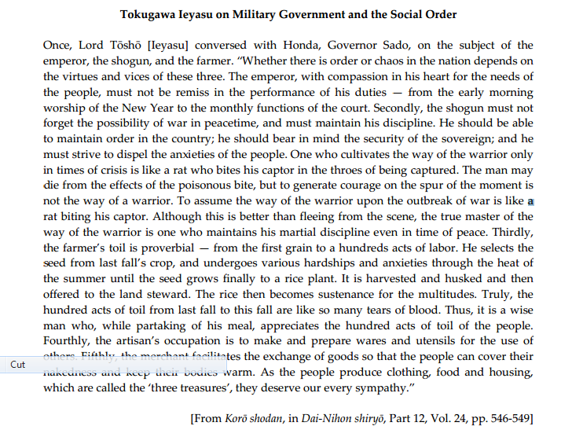
http://afe.easia.columbia.edu/ps/japan/ieyasu_four_classes.pdf

Name:
Date:

Instructions: Read and analyze the Primary document on Ieyasu Tokugawa and take a positive approach to it. In other words I want you to discuss and write all of the positive view points from this document about the Tokugawa Shogunate.

Also think of the following questions as you are reading it.

- How does Ieyasu conceive of the roles and responsibilities of the Emperor and the Shogun?

- How does Ieyasu justify the society hierarchy in Tokugawa Japan?

- Why do you think Ieyasu wanted to create a strict social hierarchy in Japan?

- What positive impacts does his views have on the people of Japan?

- How does his views help the people of Japan under his rule and views?

Black Hat
THE EDICTS OF THE TOKUGAWA SHOGUNATE: EXCERPTS FROM
LAWS OF MILITARY HOU SEHOLDS (BUKE SHOHAT TO) , 1615
Introduction

The unification of Japan and the creation of a lasting national polity in the late sixteenth and early seventeenth centuries required more than just military exploits. Japan’s “three unifiers,” especially Toyotomi Hideyoshi (1536-1598) and Tokugawa Ieyasu (1543-1616), enacted a series of social, economic, and political reforms in order to pacify a population long accustomed to war and instability and create the institutions necessary for lasting central rule. Although Hideyoshi and Ieyasu placed first priority on domestic affairs — especially on establishing authority over domain lords, warriors, and agricultural villages — they also dictated sweeping changes in Japan’s international relations.

Although the Tokugawa shogunate proved a durable political system, it lacked the elaborate legal codes and sophisticated bureaucratic apparatus of the Chinese imperial state. One of the most important Tokugawa legal documents, the Laws of Military Households (Buke Shohatto), was issued in 1615, only one year before Tokugawa Ieyasu’s death, and provided basic regulations on the behavior of lords and warriors.

The Edicts of the Tokugawa Shogunate:
Excerpts from Laws of Military Households (Buke Shohatto), 1615

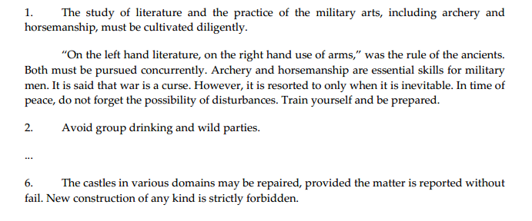
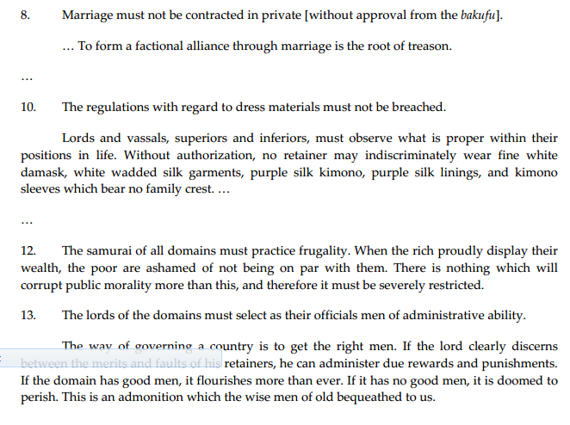
http://afe.easia.columbia.edu/ps/japan/tokugawa_edicts_military.pdf

Name:
Date:

Instructions: Read and analyze the Primary document on Ieyasu Tokugawa and take a negative approach to it. In other words I want you to discuss and write all of the negative view points from this document about the Tokugawa Shogunate and how it will not help keep this Shogunate around for long.

Also, think of the following questions as you are reading:

- What was the Tokugawa shogunate seeking to accomplish through these rules and regulations?

- Do you think that the shogunate was able to enforce these laws? How would it have done so?

- How do you think you would have reacted to these laws as a samurai at the time?

- What negative impacts do you believe this had on the people under the Shogunate rule?

- For what reasons do you think this would cause a decline in the Tokugawa Shogunate?

Blue Hat
Instructions:

Shogunate side: One third of the students will take the side of the Shogunate and argue why it is important for the Shogun to rule and not let the peasants do as they please. Use facts about the class structure from the previous lesson as well as any facts about the Tokugawa Shogunate from this lesson. Make sure to back up your arguments

Peasant side: One third of the students will take the side of the Peasants and argue that the class structure system is unfair and that you want to do away with it and the Shogunate system as well. Use facts from the previous lesson as well as facts from this lesson. Make sure to back up your arguments.

Neutral side: The neutral group of people will work in the middle of the debate and keep order for this assignment. They will take in any information that either side is demonstrating and make an unbiased judgment through that. They will also be in charge that things do not get out of hand and facilitate the discussion.

Red Hat

Instructions: On a separate piece of paper, write about the gut feeling you had while first learning about the Tokugawa Era. Did you feel that it would last longer than it did or did you believe that it was going to fall in due time. Write every emotion and every hunch that you felt as you were slowly approaching the answer to this question and finish this by stating whether your gut feeling was right or wrong. Give many examples and support your answers with facts from the lesson.
Also, watch “The Decline of the Tokugawa Shogunate” video to help you better understand the reasons as to why the long reigning Shogunate fell.

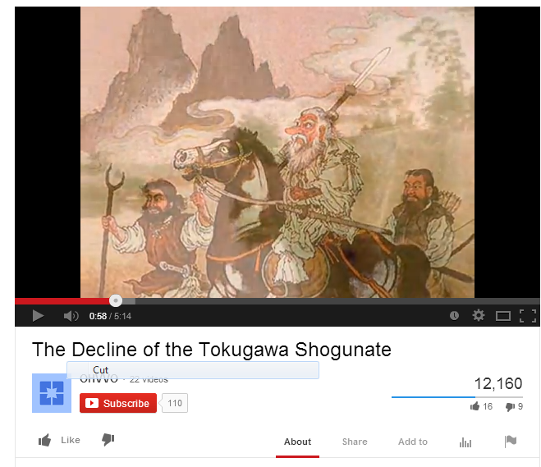
http://www.youtube.com/watch?v=yYQnQb8OBEc

Green Hat
Name:
Date:

Instructions: It is now time for you to create your own Shogunate. With all of the information that you have acquired throughout this lesson, I want you to make your own Shogunate. You can model this after the Tokugawa Shogunate or you can make it up all on your own, it is all up to you. Keep in mind that if you want to use previous edicts of Ieyasu Tokugawa, you will have to give reasoning as to why you want to use that edict or if you want to eliminate one completely you will have to do the same. Include if you want to keep the class system or not and how that would affect your Shogunate.

______________________________________________________________________________________________________________________________________________________________________________________________________________________________________________________________________________________________________________________________________________________________________________________________________
______________________________________________________________________________________________________________________________________________________________________________________________________________________________________________________________________________________________________________________________________________________________________________________________________
______________________________________________________________________________________________________________________________________________________________________________________________________________________________________________________________________________________________________________________________________________________________________________________________________
____________________________________________________________________________________________________________________________________________________________

